Microsoft Visual Studio Build Issue

Course: COEN-243
Professor: Dr. Moataz Chouchen
Location: H-833 computer workstations

Context
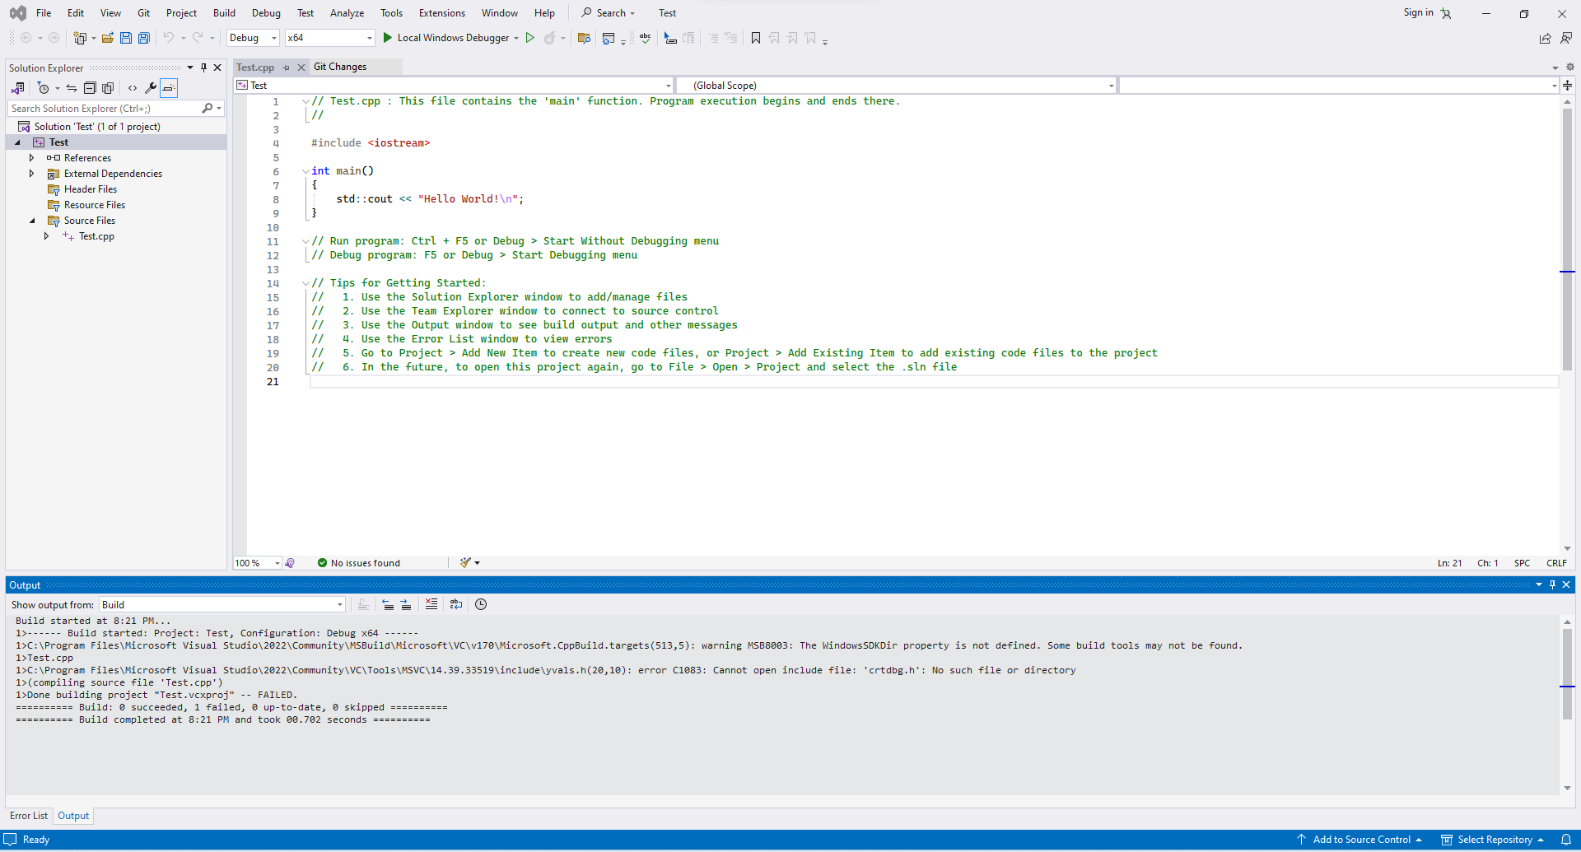
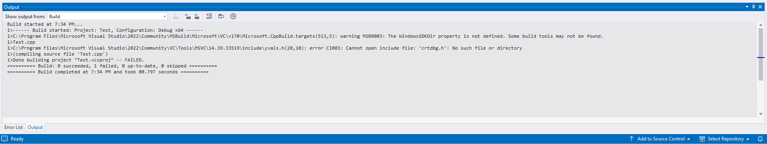
I attempted to compile a classic “Hello World” program in C++ using Microsoft Visual Studio that comes installed on the computer workstations in H-833. Despite the simplicity of this program, the build process would fail in the following way:
warning MSB8003: The WindowsSDKDir property is not defined. Some build tools may not be found.
Here are screenshots of the program and build output:

Build failed!

Figure 1 & 2: “Hello World” program and build output
Debugging
From the debugging that I have performed, I have been able to conclude the following:
- The “Desktop development with C++” option is checked in VS Installer.
- Correct components from the above-mentioned are listed as installed.
- The project in VS is configured correctly according to many guides.
- There is no antivirus interfering with VS.
However, there seems to be an issue with the Windows SDK installation on the computers. Although it is listed as installed in VS Installer, I noticed the following:
- Under Project Properties -> General, the SDK Version dropdown only shows “inherit from parent or project defaults”.
- There is no explicit SDK version shown.
- The environment variable WindowsSDKDir is not defined.
- The “Include” folder is missing from the following directory:
C:\Program Files (x86)\Windows Kits\10\Include
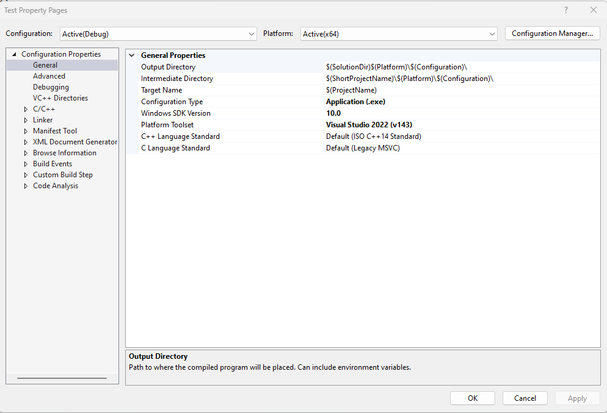
Here are some more screenshots:
Under this dropdown, there is no explicit SDK version available to be specified!

Figure 3: project properties window with improper SDK installation
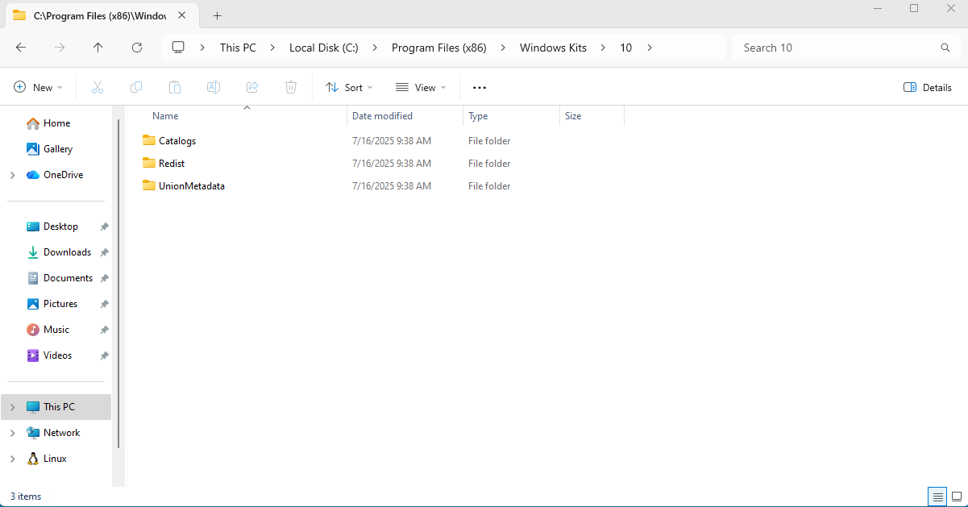
Figure 4: missing critical folder
Where is the “Include” folder?
C:\Program Files (x86)\Windows Kits\10\

Cause
According to my research, VS relies on the SDK Include and Lib directories to configure the C++ build environment. Since this installation seems to be incomplete, VS runs into the following issues:
- MSBuild can’t fully initialize the toolchain.
- The project cannot correctly bind to a SDK version.
- We get the MSB8003 warning no matter what code we try to build.

Solution
Fixing this issue requires the use of administrator rights (elevated rights) on all the computers. The SDK installation needs to be examined closer if it’s the case that it’s truly installed, but in another directory, otherwise the SDK installation needs to be redone completely.
Another possible solution would be to use another IDE that is installed on the computers, such as PyCharm, although some people might prefer the use of Visual Studio over PyCharm.

Proof
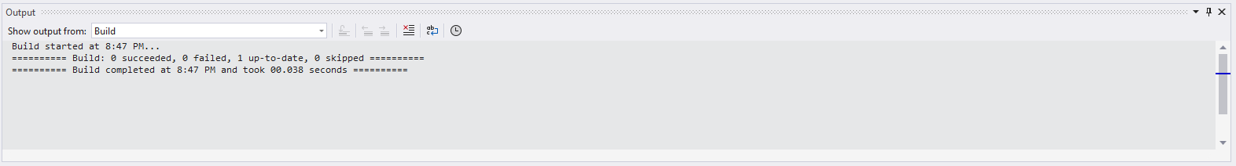
After realizing that the installation of VS on the computers in H-833 was questionable, I went to H-815 to test its installation of VS on their computers. The screenshots below show that with the same code and configuration, the build process is completed without any issues. In addition, I also ran the code that I wrote for my lab assignment without issues:

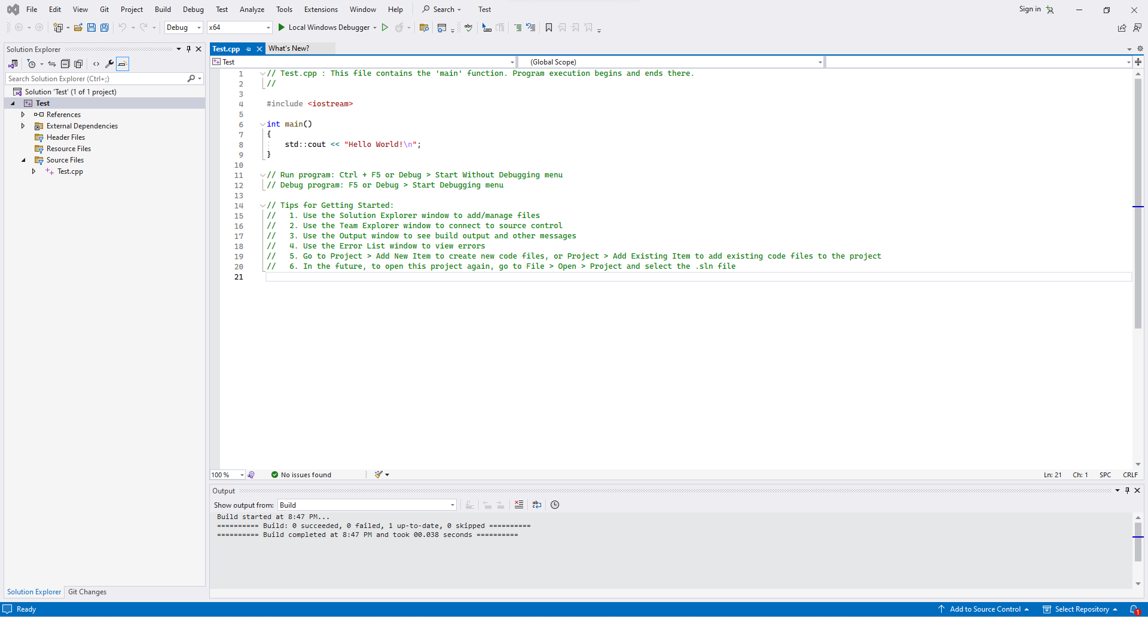
Figure 5: successful build output

Build succeeded!
Figure 6: “Hello World” program from before

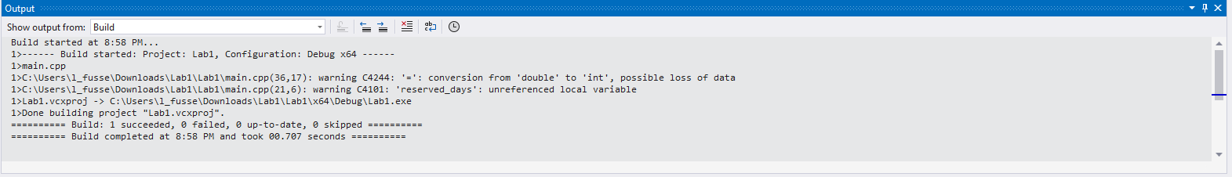
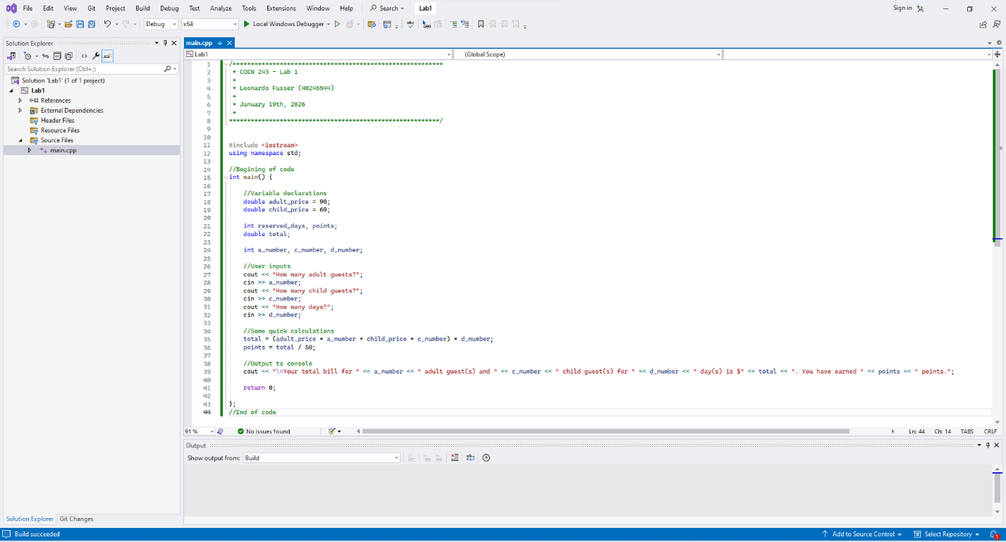
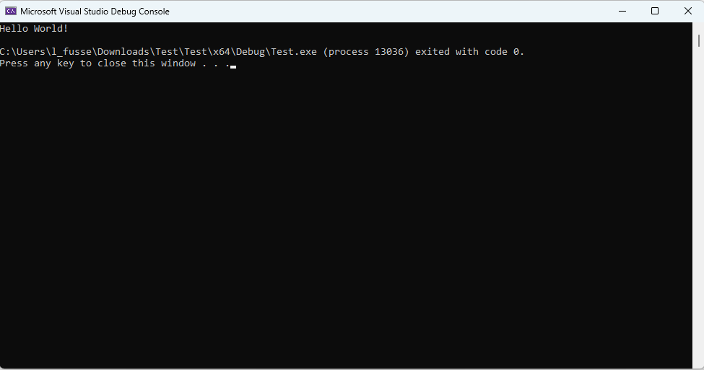
Figure 7: “Hello World” output on console
Build succeeded!

It’s alive!

Figure 8 & 9: lab program and build output
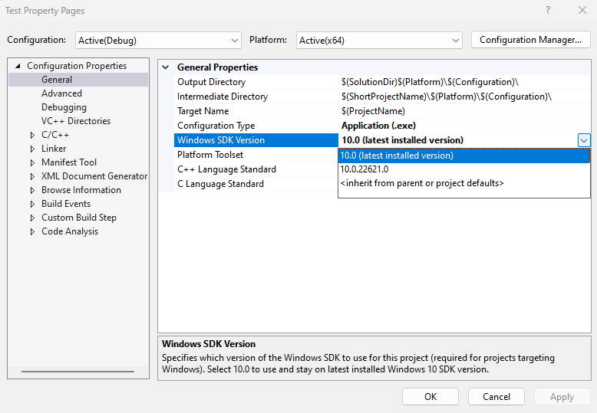
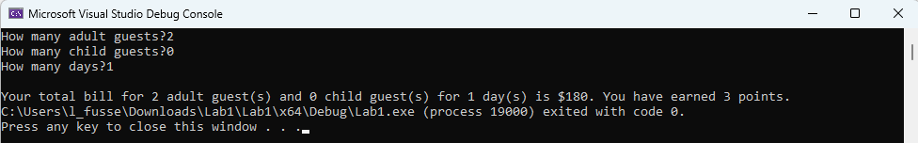
Figure 10: lab program output on console

Under this dropdown, we can see that there are explicit SDK versions available!

Figure 11: project properties window with proper SDK installation

Conclusion
The issue that I found with the installation of Visual Studio on the computers in H-833 is unrelated to the code being built or project structure. From my research, it is caused by a broken SDK installation on the computers, which prevents Visual Studio from correctly building code. Resolving this requires administrative intervention.

